In Class Assignment 3

Genesis Grant

CTEC 402

|  |  |  |
| --- | --- | --- |
| Question: | My Answer | ChatGPT Answer |
| How to Encrypt Files on Your Computer | To encrypt files, use security features on your device or download trusted encryption software for more options. Choose a strong, unique password that’s hard to guess, and make sure to store it securely in case necessary later. | To encrypt files on your computer, you can use built-in tools or third-party software. On Windows, BitLocker is available for disk encryption, while macOS users can utilize FileVault. You can also use software like VeraCrypt or AxCrypt for individual files or folders. Choose a strong password for added security, and store it safely. With command-line options like OpenSSL or GPG, you can encrypt files directly if you're comfortable with technical steps. |
| What Are the Benefits of Encrypting Sensitive Files on Your Computer? | Encrypting sensitive files is important for keeping private data safe from unauthorized access. It adds an extra layer of protection that helps ensure your personal, financial, or work-related information remains secure. | Encrypting sensitive files protects your data from unauthorized access and keeps it secure even if your computer is lost, stolen, or hacked. It prevents identity theft and ensures that sensitive information—like financial data, personal records, or business documents—remains private. Encryption is essential for complying with data privacy regulations and helps build trust with clients or users by safeguarding their information. |
| What Files Do You Need to Encrypt? | You should encrypt any files containing sensitive details, such as personal records, financial data, or confidential documents. This is especially important for files stored on portable or shared devices, which can be more vulnerable to unauthorized access. | You should encrypt files containing sensitive personal information, financial records, confidential work documents, and anything else you wouldn’t want others to access if they got hold of your device. This includes tax documents, health records, passwords, and any personal data. It’s especially important for files stored on portable devices like laptops or external drives, which can be easily lost or stolen. |
| How to Recover Encrypted Files Without a Password? | Some encryption tools provide recovery options, such as a backup key, but if not available, you might need to consult a professional recovery service or contact the software company. Though, if forgotten it is possible it will never be restored. | Recovering encrypted files without the password is difficult by design, as encryption is meant to protect data from unauthorized access. However, you might try accessing a recovery key if you used a program that provides one (like BitLocker on Windows). In some cases, specialized recovery tools or services may help, but they can be costly, and success isn’t guaranteed. If all else fails, consult a professional data recovery service, but note that bypassing encryption without the proper key may be impossible. |

**HOW TO SET UP NETWORK PERMISSIONS FOR USER ACCOUNTS**

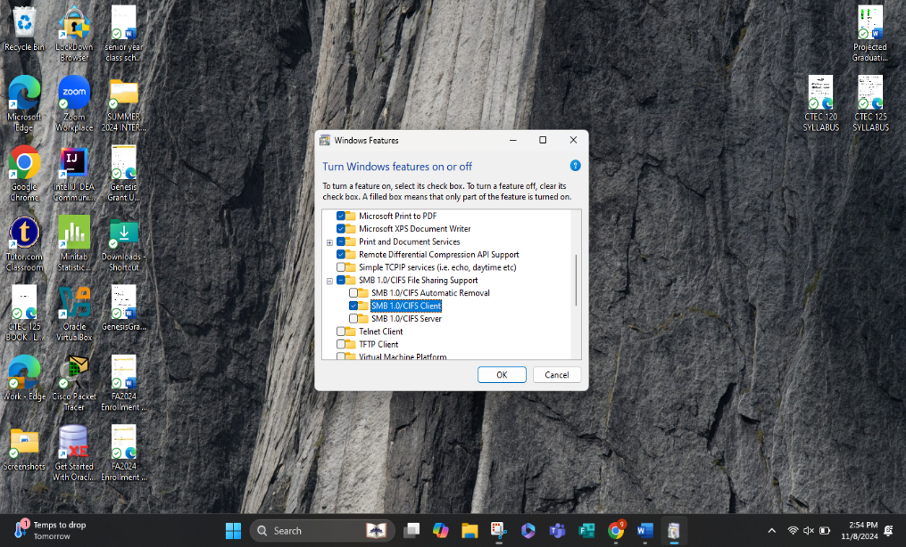

1.Using the search tool in the taskbar

look up and select windows features.

in this window now look for SMB

file Sharing Support and select

SMB Client. Itll will proceed to

download documents.

2. After applying the changes, the system will

Restart.

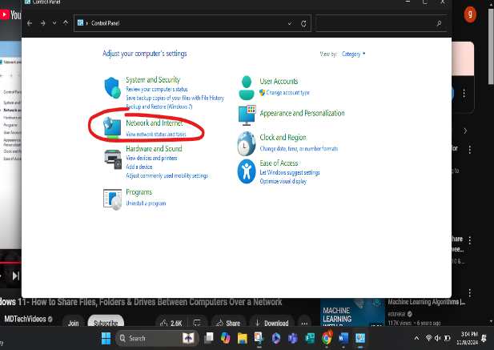

3. Navigate to your control panel and select

Network and Internet.

4. Select Network and Sharing Center.

5. Select ‘Change advanced sharing settings’.

6. In this window if you want your device to be

Discoverable by others on the network, turn on

‘Network Discovery’ on private and/or public networks.

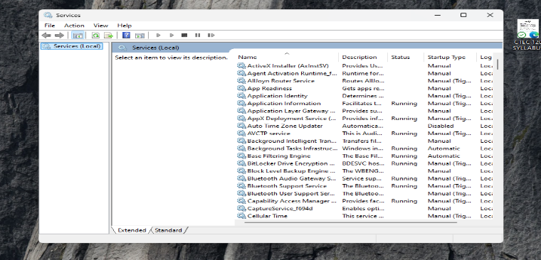7. Use the taskbar to find and select services.

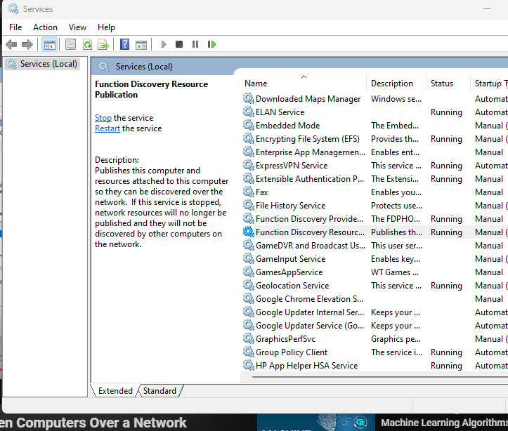8. Find and select Function Discovery

Resource Publication. Start this service.